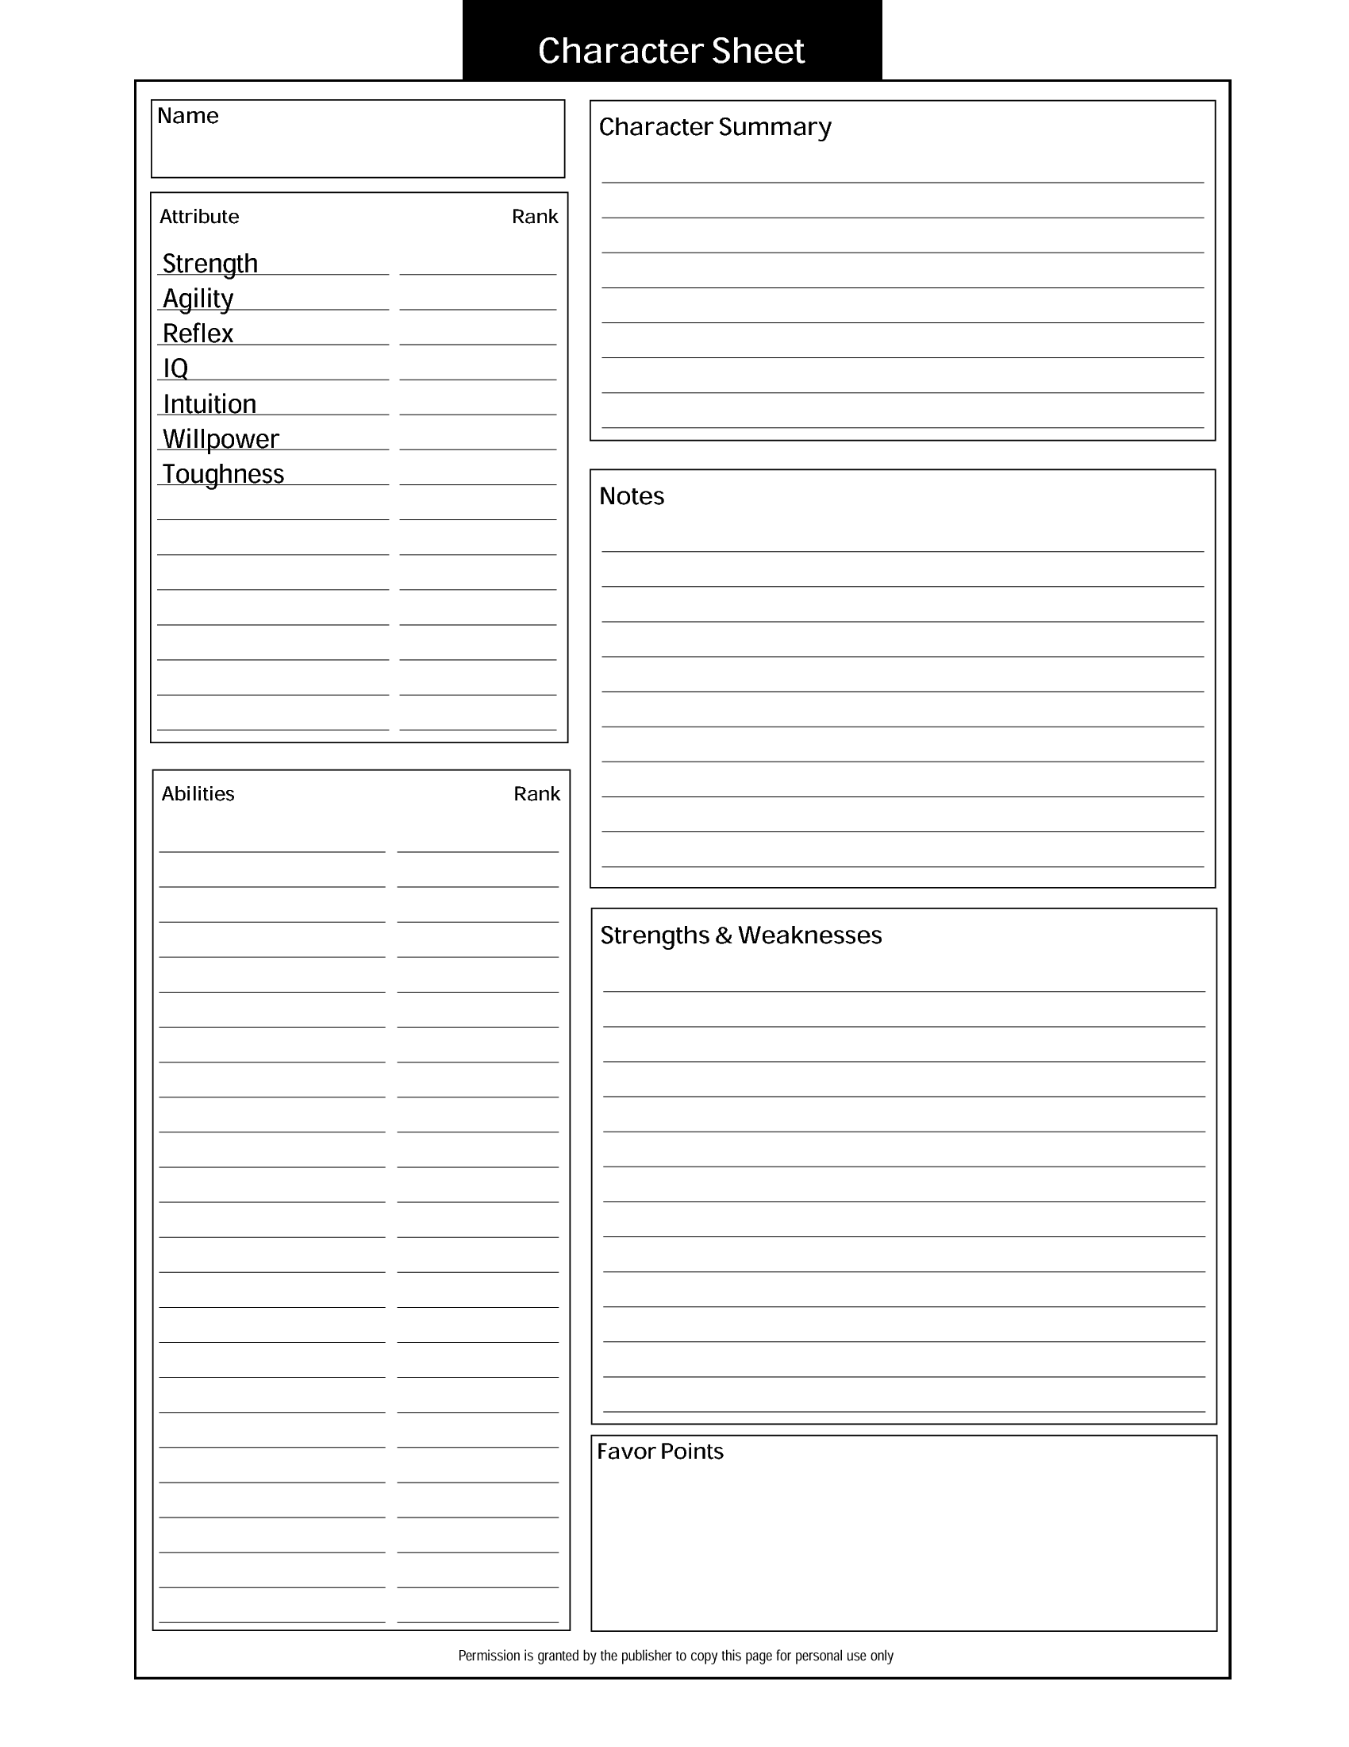

Aelion is a young monk, who is skilled in swordplay, and is just starting to understand his ability to control arcane forces. More specifically, he'll have to decide what arcane force he will eventually settle into. Will it be elemental (fire, water, air, lightning), illusion (illusion spells), telekinetics (the ability to push and pull objects), or control of the mind. It is rumored that there is an arcane skill that controls all of them, even the force of life.

50

Average

Average

Average

Air (increases Agility/Reflex)

Mind Control

Telekinetics

Sword Play

Exceptional

Average

High

High

High

Above Average

Average

Average

Aelion